Cloud-Agnostic Infrastructure Automation

Author: Dhanush V
Role: MCA Graduate | Cloud & DevOps
GitHub Repository: git@github.com:dhanushv4/cloud-agnostics.gitS

Project Overview
This project automates cloud infrastructure deployment using Terraform and Ansible while supporting multiple cloud providers through a single configuration file.
Instead of manually creating virtual machines, security groups, and software installations, the project generates Terraform files automatically, deploys infrastructure, configures servers using Ansible, verifies deployment, and cleans up resources when no longer required.
The objective is to demonstrate Infrastructure as Code (IaC), automation, and cloud provisioning skills suitable for Cloud and DevOps Engineer roles.

Objectives
- Automate infrastructure provisioning.
- Support multiple cloud providers.
- Use Infrastructure as Code.
- Configure servers automatically.
- Reduce manual deployment effort.
- Demonstrate DevOps automation workflow.

Technologies Used
Category | Technology
Cloud | AWS
IaC | Terraform
Configuration | Ansible
OS | Ubuntu Linux
Scripting | Bash
Version Control | Git
Repository | GitHub
SSH | OpenSSH

Project Architecture

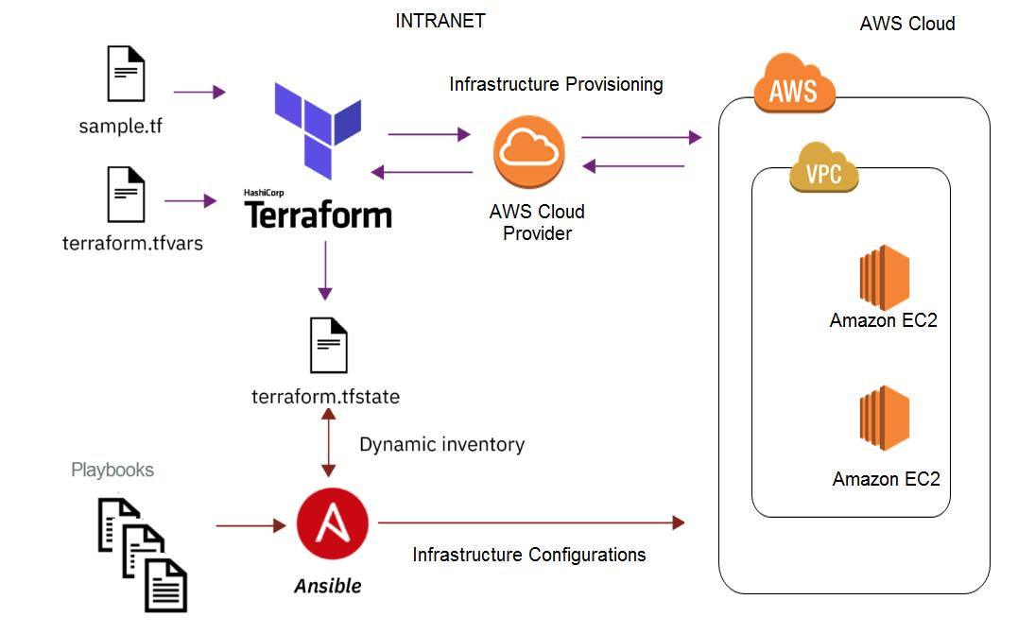

Workflow
- User edits infra.conf.
- Bash script reads configuration.
- Terraform files are generated.
- Terraform provisions infrastructure.
- EC2 instance is created.
- Security Group is configured.
- Ansible connects through SSH.
- Required packages are installed.
- Validation scripts verify deployment.
- Infrastructure can be destroyed automatically.
Project Structure
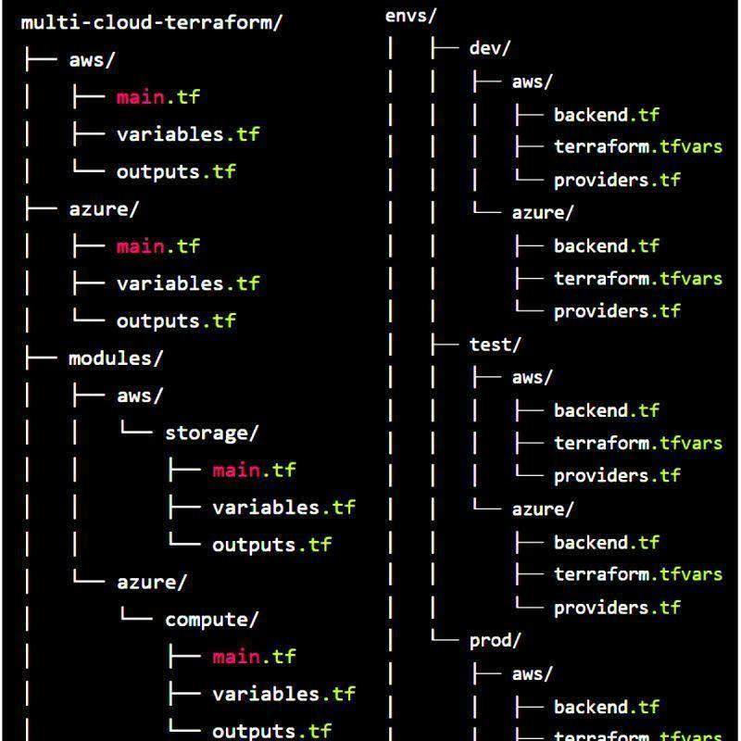
cloud-agnostics/
│
├── infra.conf
├── generate.sh
├── terraform/
│ ├── main.tf
│ ├── variables.tf
│ ├── outputs.tf
│ └── terraform.tfvars
│
├── ansible/
│ ├── docker.yml
│ ├── nginx.yml
│ ├── cleanup.yml
│ └── validate.yml
│
├── scripts/
│ ├── terraform-init.sh
│ ├── terraform-apply.sh
│ ├── verify.sh
│ └── destroy.sh
│
└── README.md

Configuration File
The project is controlled through a single configuration file named infra.conf.
Example:
CLOUD_PROVIDER="aws"

AWS_REGION="ap-south-1"

INSTANCE_COUNT="1"

INSTANCE_TYPE="t2.micro"

TAG_NAME="cloud-demo"

SSH_USER="ubuntu"

SECURITY_GROUP="cloud-demo-sg"
This allows infrastructure settings to be changed without modifying Terraform code.

Terraform Implementation
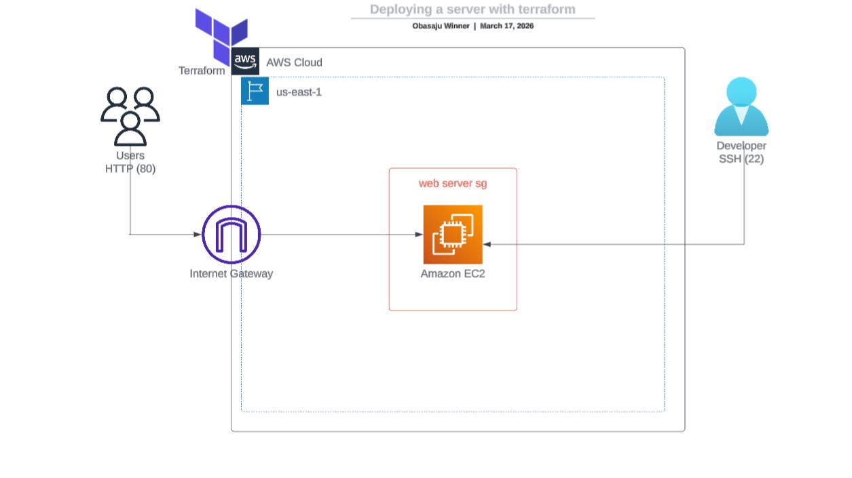
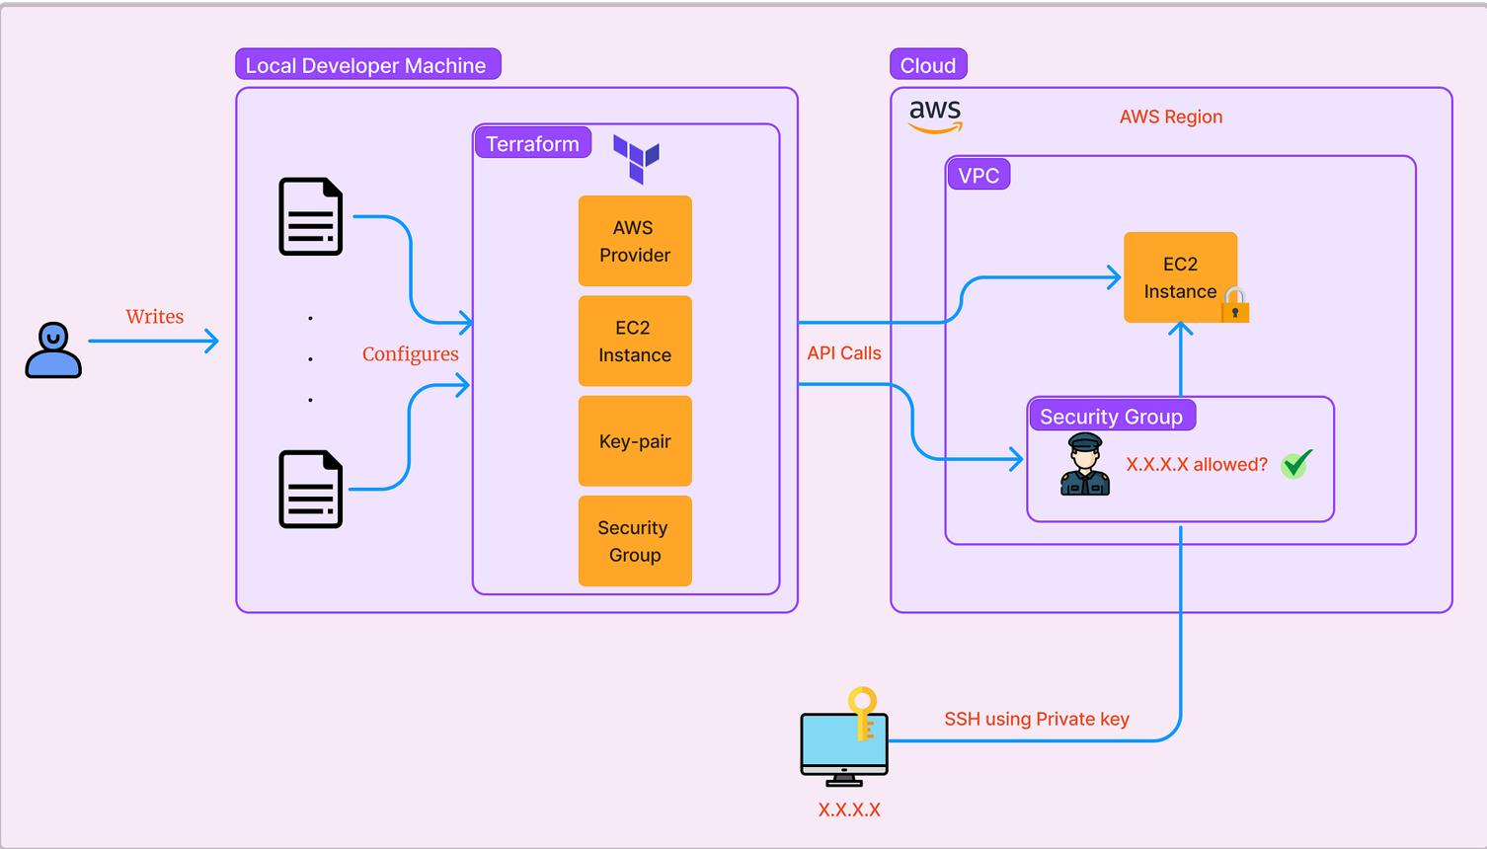
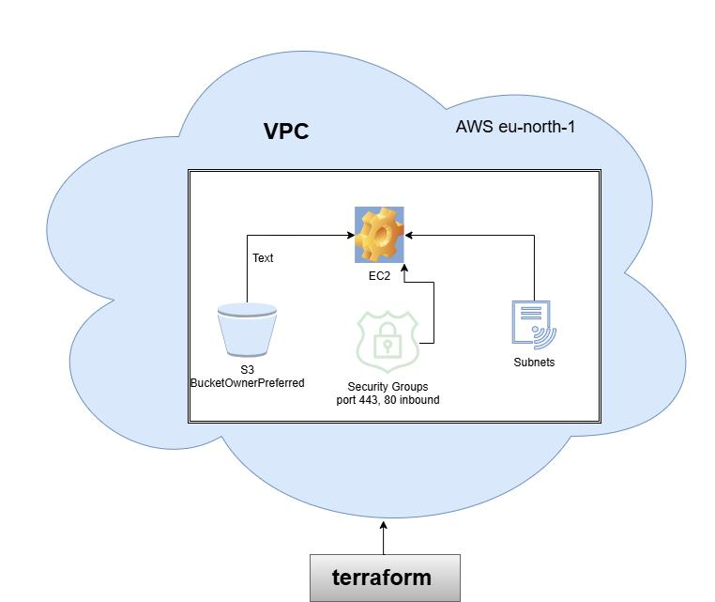

Terraform performs the following tasks:
- Creates EC2 instances.
- Creates Security Groups.
- Opens SSH access.
- Tags cloud resources.
- Produces outputs such as Public IP.
Example command:
terraform init
terraform apply
Outputs include:
- Public IP
- Instance ID
- SSH connection details
Ansible Automation
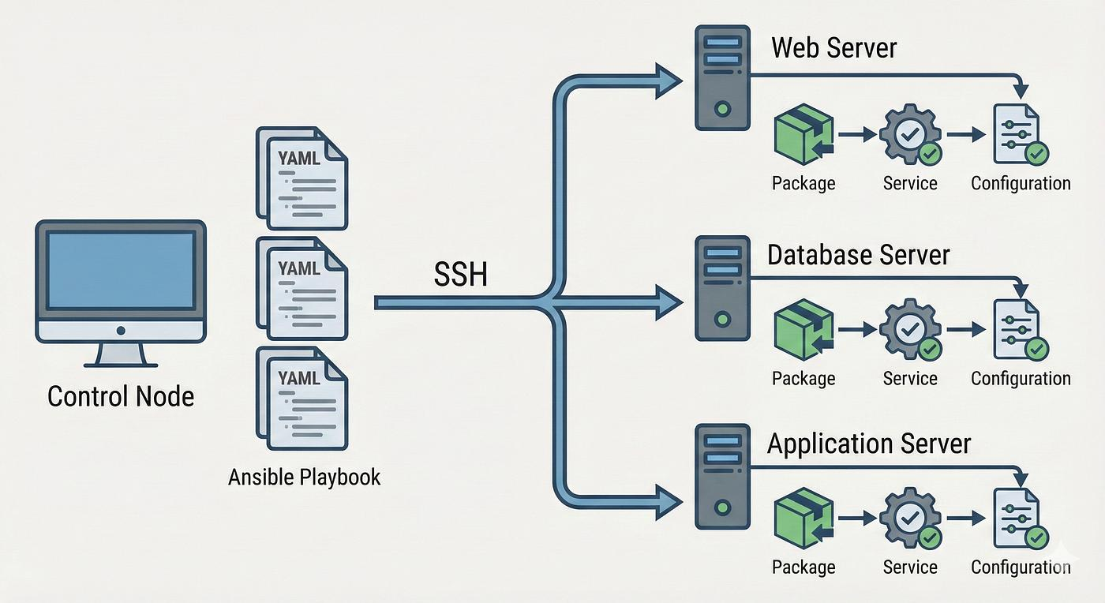
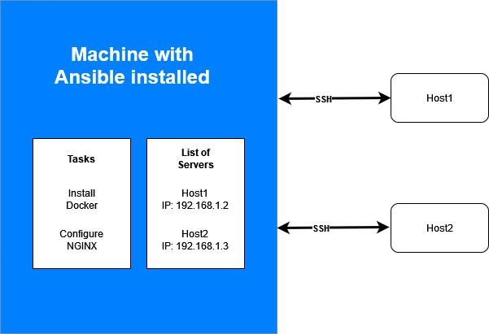
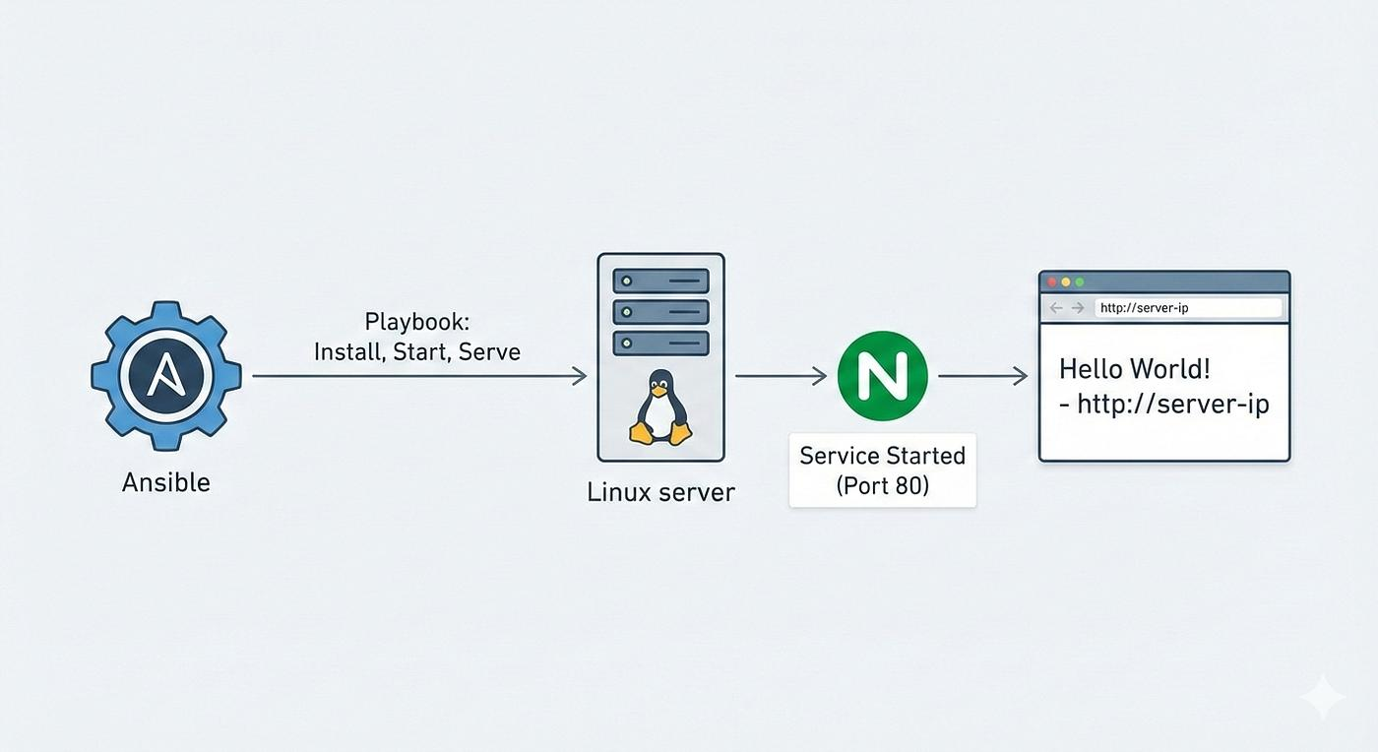
After Terraform creates the server, Ansible automatically configures it.
Playbooks include:
- Docker installation
- NGINX installation
- Validation
- Cleanup
Example:
ansible-playbook docker.yml
ansible-playbook nginx.yml
Deployment Process
Step 1
Configure infrastructure.
nano infra.conf
Step 2
Generate Terraform files.
./generate.sh
Step 3
Initialize Terraform.
terraform init
Step 4
Deploy infrastructure.
terraform apply
Step 5
Connect through SSH.
ssh ubuntu@PUBLIC_IP
Step 6
Run Ansible playbooks.
ansible-playbook nginx.yml
Step 7
Validate deployment.
./verify.sh
Security Configuration
The project follows basic cloud security practices.
Implemented:
- Security Groups
- SSH access control
- Ubuntu user login
- Infrastructure tagging
- Automated cleanup
Verification
Deployment verification includes:
- SSH connectivity
- NGINX status
- Docker installation
- Running services
- Server accessibility
Example:
systemctl status nginx

docker --version

Cleanup Process
Infrastructure can be removed completely.
terraform destroy
This deletes:
- EC2 instances
- Security Groups
- Associated cloud resources
Key Features
- Infrastructure as Code using Terraform
- Automated server configuration using Ansible
- Single configuration file
- Cloud-ready deployment workflow
- Automated validation
- Automated cleanup
- Reusable deployment process

Challenges Faced
During development several issues were resolved:
- Terraform variable configuration
- SSH connectivity
- Security Group permissions
- Ansible inventory generation
- Infrastructure validation
- Automated deployment workflow
These improvements made the deployment process more reliable.

Skills Demonstrated
Cloud
- AWS EC2
- Security Groups
- Infrastructure deployment

DevOps
- Terraform
- Ansible
- Git
- Bash
- Linux
- SSH
Automation
- Infrastructure provisioning
- Server configuration
- Validation scripts
- Resource cleanup

